Introduction

“Mosquito Hunter: Generations Ultimate” is a RPG style game. The main goal of the game is to purchase a final boss ticket and defeat the final boss. Gold can be obtained by killing mosquitoes in the “Battle” menu. Other than the final boss tickets, different hands can be purchased and each has a different ability. Power-ups can also be purchased in the shop to aid the player in battling. The final boss introduces a new mechanic in the game which is similar to space invaders. There are different stages of mosquitoes, it gets stronger as the stage number gets higher, and more gold will be rewarded for a higher stage mosquito.

Why this app?

The reason for creating this game is for entertainment. I also always wanted to make a game when I was younger, so I took this final project as an opportunity.

APIs

* Pygame

Start Menu

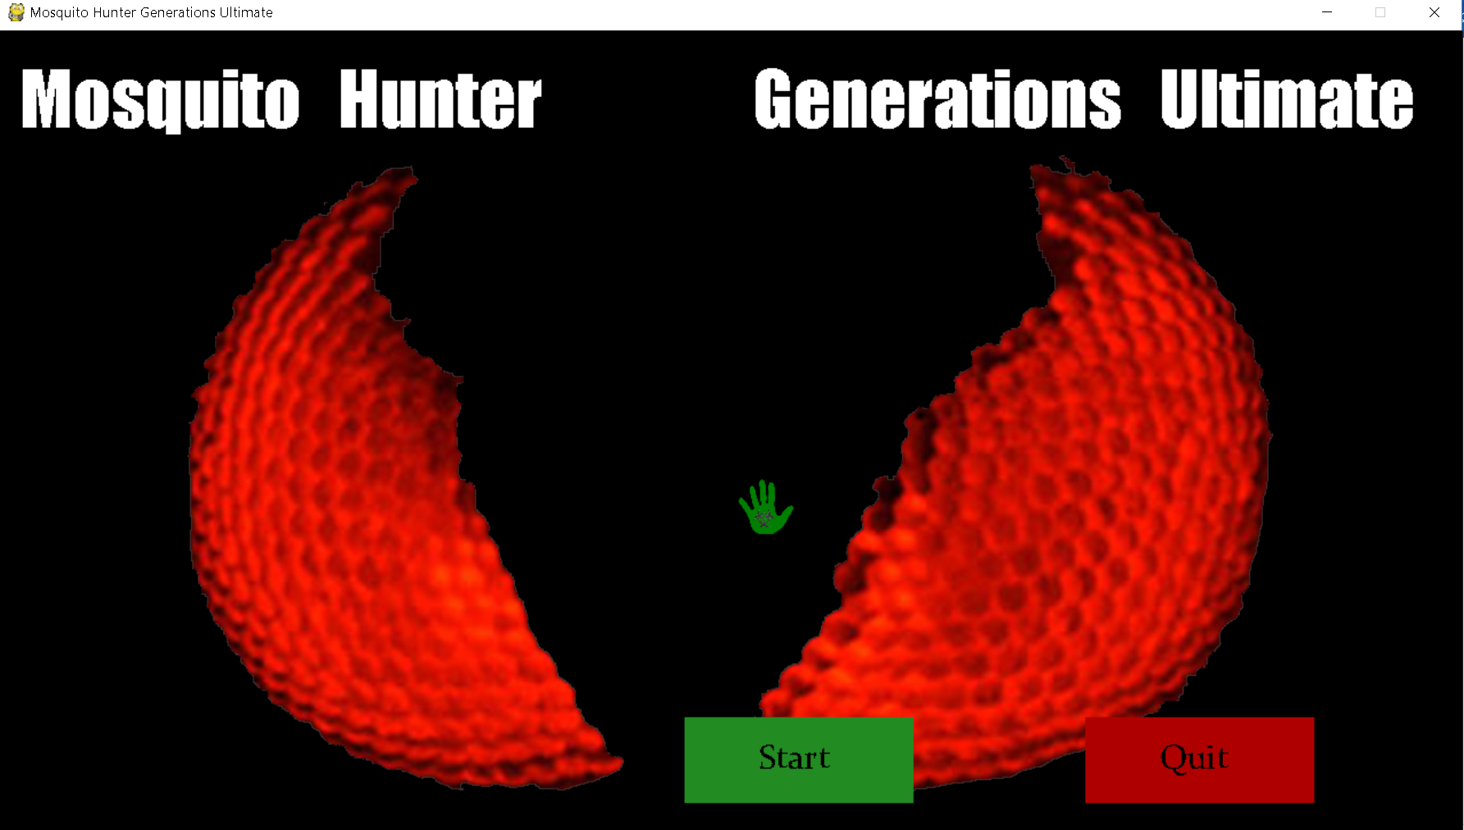

Main Menu

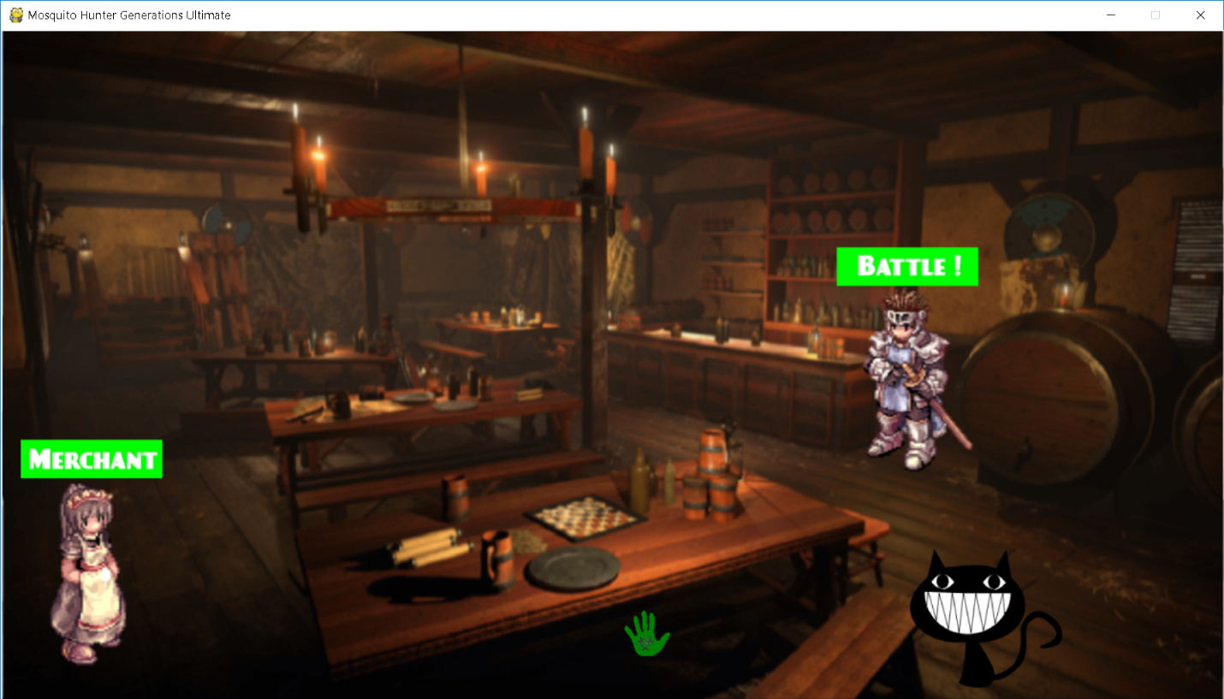

Stage Select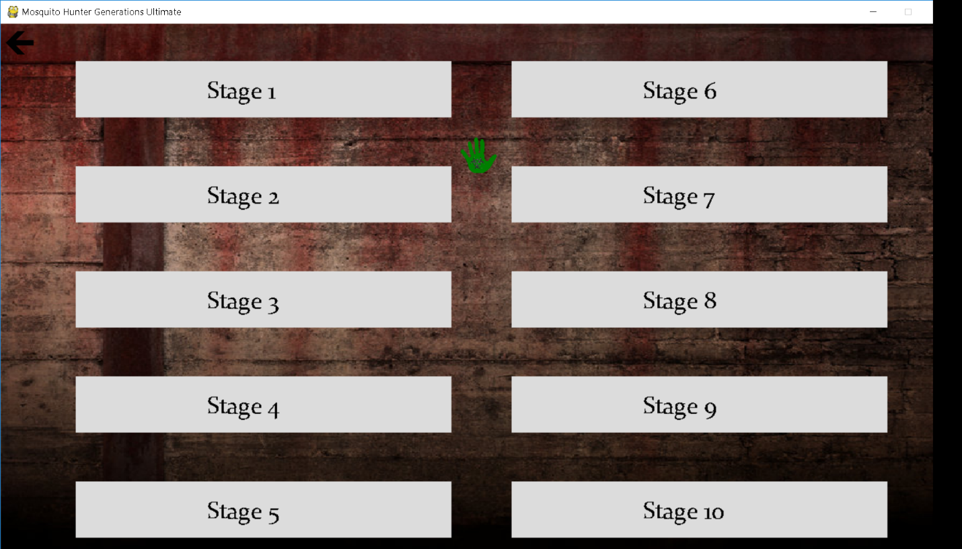

Mosquito Hunt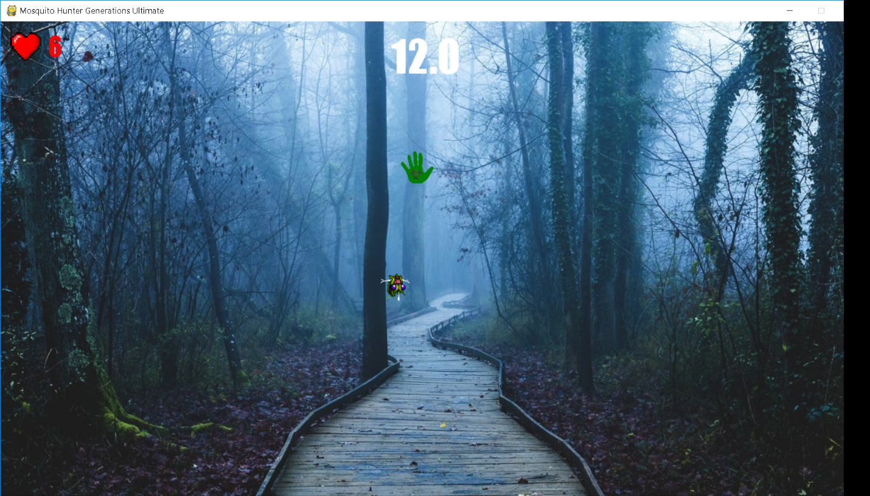

Merchant Menu

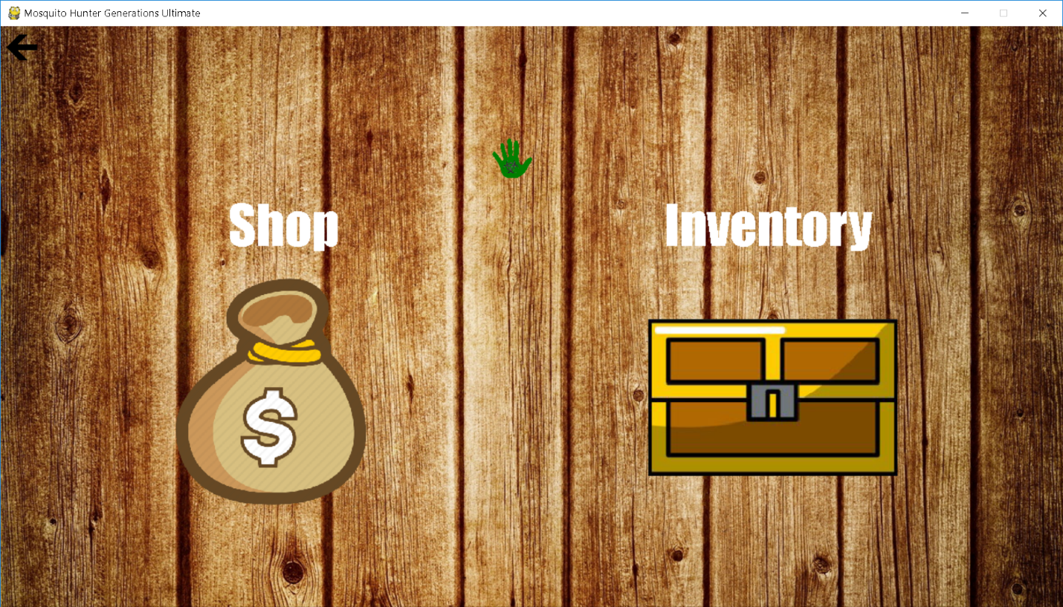

Shop Menu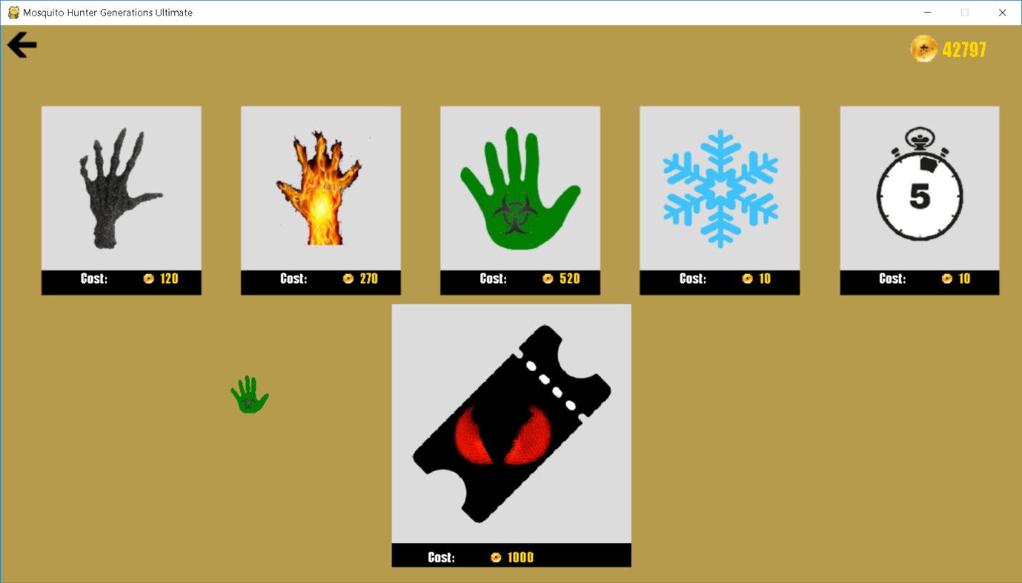

Inventory

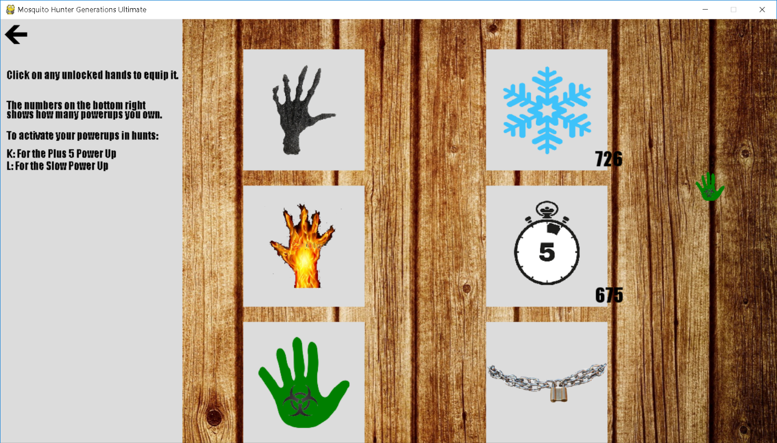

Boss Battles